Assignment-I
CLO-01: Use concept of elementary row operations to find the inverse of square matrices, determinant of a matrix and solving the system of linear equations. Attempt the following problems from Elementary Linear Algebra by Howard Anton and Anton Kaul (12th Edition).

Chapter no. 1:
Exercise 1.1: | Q:12, Q:16(b), Q:17(a), Q:20(a)
Exercise 1.2: | Q:6, Q:18, Q:22, Q:26, Q:27, Q:34
Exercise 1.3: | Q:12(a), Q:14(b), Q:23
Exercise 1.4: | Q:9, Q:27, Q:38, Q:45(a)
Exercise 1.5: | Q:9(b), Q:10(a), Q:11(b), Q:12(b), Q:26
Exercise 1.6: | Q:6, Q:15, Q:17, Q:19, Q:20
Exercise 1.7: | Q:13, Q:14, Q:25 to 28, Q:42

Question: The accompanying figure shows a network of one-way streets with traffic flowing in the directions indicated. The flow rates along the streets are measured as the average number of vehicles per hour. Consider the traffic flow described by the following diagram.
- Set up a linear system whose solution provides the unknown flow rates.
- Solve the system for the unknown flow rates.
- Is it possible to close the road from 𝐴 to 𝐵 for construction and keep traffic flowing on the other streets? Explain.
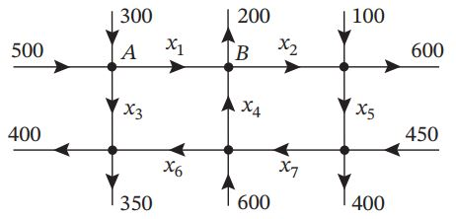

Chapter no. 2:
Exercise 2.1: | Q:24, Q:25, Q:26, Q:33(b), Q:36
Exercise 2.2: | Q:3, Q:12, Q:14, Q:16 to 21, Q:23
Exercise 2.3: | Q:17, Q:18, Q:23, Q:28, Q:29, Q:30, Q:31

